Restriction Endonuclease Digestion of DNA

Restriction Endonuclease Enzymes:
- Restriction endonucleases, or restriction enzymes, are proteins that can recognize specific, short DNA sequences (usually 4-8 base pairs long) and introduce a cut at or near these sites.
- These enzymes are naturally found in bacteria, where they serve as a defense mechanism against potentially harmful DNA (e.g. from viruses) by cutting it into smaller, non-functional pieces.
- Restriction enzymes are classified into three main types (Type I, II, and III), with Type II being the most commonly used in laboratories due to their ability to cleave DNA at precise locations within a recognizable sequence.
- Each restriction enzyme has a unique recognition site, typically a palindromic sequence, which means the sequence reads the same forward and backward.
- The specific nature of cutting (blunt ends or overhangs/sticky ends) depends on the enzyme used.
- Let’s consider an example to understand the difference between blunt and sticky ends.
- Restriction endonuclease A recognizes, binds and cleaves the palindromic sequence GAATCC and cleaves the DNA between the G and A bases, creating sticky ends, as shown in Figure A below.
- Restriction endonuclease B recognizes, binds and cleaves the palindromic sequence CCCGGG. It cleaves the sequence evenly generating blunt ends (Figure B)
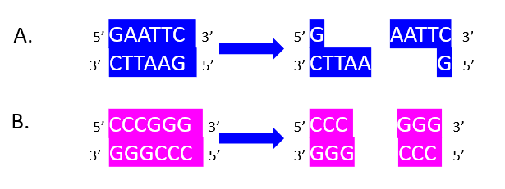

Molecular Cloning:
Restriction digestion is critical in cloning procedures, where DNA fragments of interest are inserted into vectors (like plasmids) cut with the same restriction enzymes (A & B) to ensure compatibility. This generates sticky ends for both the target gene and the plasmid in this example (C and D). Ligation leads to insertion of the target gene into the plasmid (E), which can now introduce the DNA fragment into host cells, allowing its replication and expression. This process is fundamental for gene manipulation, producing recombinant proteins, and creating genetically modified organisms.

